**0.9% Sodium Chloride Injection Flush Syringe**

**Instruction for Use (IFU)**

1. **Device or Trade Name**

Device name: 0.9% Sodium Chloride Injection Flush Syringe

Trade name: HP FlushTM

1. **Manufacturer and Address**

Manufacturer**:** Zhejiang Hope Pharma Co., Ltd.

Address: Building 2 & Building 4 (Level 2 & 3 East), No. 1568 1st Binhai Avenue, Wenzhou Economic & Technological Development Zone, Wenzhou, Zhejiang, P.R.C., 325000

Tel: +86 13506510618

1. **EU Authorized Representative and** **Address**

EU Authorized Representative: MedPath GmbH

Address: Mies-van-der-Rohe-Strasse 8, 80807 Munich, Germany

1. **Basic UDI**

Basic UDI: 697611457C3C0034K

1. **Device Description**

The 0.9% Sodium Chloride Injection Flush Syringe is a sterile, single-use medical device composed of a polypropylene plastic syringe prefilled with 0.9% sodium chloride for injection, USP. Each syringe is sealed with a polypropylene tip cap. The syringe content is sterile, non-toxic, and non-pyrogenic.Each syringe is individually packaged in a polyethylene (PE) bag. The solution complies with the specifications outlined in the United States Pharmacopeia (USP) <40> monograph for sterile normal saline for injection.

**Specifications Variant Description**

|  |  |
| --- | --- |
| **Specifications** | **Contents** |
| HBYC-3 mL | 0.9% Sodium Chloride Injection Flush Syringe, 3 mL fill in 5 mL syringe |
| HBYC-5 mL | 0.9% Sodium Chloride Injection Flush Syringe, 5 mL fill in 5 mL syringe |
| HBYC-10 mL | 0.9% Sodium Chloride Injection Flush Syringe, 10 mL fill in 10 mL syringe |

1. **Intended Use**

HP Flush TM 0.9% Sodium Chloride Injection Flush Syringe is intended for flushing only in-situ vascular access devices.

HP Flush TM 0.9% Sodium Chloride Injection Flush Syringe is not intended for dry product reconstitution,for medication dilution,or where intravenous therapy with sodium chloride is indicated.

1. **Intended User**

This device is for use only by healthcare professionals trained in vascular access procedures and experienced with this type of device.

1. **Patient Population**

HP Flush TM 0.9% Sodium Chloride Injection Flush Syringe is to be used with patients with in-situ peripheral intravenous catheters (PIVCs), peripherally inserted central catheters (PICCs), central venous catheters (CVCs), and implanted venous access ports. The product has no age restriction on the patient population. It includes both neonates, children and adults.

1. **Contraindications**

No known contraindications.

1. **Use Environment**

The device is intended for use in clinical settings within non-sterile environments.

1. **Side Effects, Interactions, and Complications**

Section 5 of Chapter 38 'Flushing and Locking' in the *Infusion Therapy Standards of Practice* *(2024)* published by the *Infusion Nurses Society (INS)* describes potential product-related adverse effects:

*—5.If a patient reports disturbance in taste and odd / smell, inform them that prefilled flush syringes are occasionally associated with this and that it has been found to be more prominent when flushing central venous access devices (CVADs) than with peripheral intravenous catheters (PIVCs). The cause is thought to be substances leaching from the plastic syringe due to sterilization methods. These sensations may be significant enough to impact appetite and may increase nausea, especially if administered rapidly. This sensa-tion can be minimized with a slower injection rate. Reassure patient that sensation will subside when injection / flush has ceased.(III)*

The above information represents the current authoritative clinical standards regarding potential adverse effects associated with this product, as identified through our comprehensive literature review. These clinical observations are supported by moderate-level evidence (Grade B) derived from a randomized controlled trial involving 50 pediatric patients (age range: 6-18 years). ***(****Taste and Odour Disturbances in Pediatric Patients Undergoing IV Flush with Normal Saline Administered by Prefilled or Freshly Prepared Syringes: Randomized Single-Blind Study, David Mancini, Régis Vai lancourt, 2014),*Therefore, this provision shall be subject to periodic review and necessary updates in accordance with ongoing post-market clinical evaluation.

B.Possible complications and/or adverse reactions associated with flushing may include sepsis, infections (localized/systemic), mucocutaneous blood exposure, exposure to bloodborne pathogens, air embolism, particulate embolism, blood clots, phlebitis, leakage that may lead to hazardous drug/fluid exposure, irritation, a transitory taste or odor during flushing. Use of a contaminated normal saline product may lead to infection and possibly death.

C.Not using aseptic technique and failure to adhere to flushing guidelines may lead to: catheter related bloodstream infection and related injury or death, catheter failure, catheter related complications such as occlusion, infiltration, extravasation, erythema, swelling or pain.

1. **Sterilization**

The device is sterilized by moist heat.

1. **Storage**

* Store at 20-25 ℃ (68-77 ℉).
* Do not freeze.

1. **Warnings**
2. Do not place the syringe on a sterile field.
3. Do not use after the expiration date.
4. Do not use if packaging is damaged or not intact.
5. Do not use if there is evidence of leakage.
6. Do not use if the syringe tip cap is detached.
7. Do not use if the solution appears discolored, cloudy, hazy, contains precipitate, or shows any visible foreign matter.
8. Do not re-sterilize the device.
9. **Caution**
10. For intravenous flush use only.
11. Only the fluid path is sterile.
12. Use only under the supervision of a physician or licensed healthcare practitioner.
13. Not intended for the injection of medications.
14. For single-use only; reuse may result in infection or injury.
15. Follow institutional policies and applicable regulations.
16. Re-use may lead to infection or other diseases/injuries.
17. In 2024, the Infusion Therapy Standards of Practice (Infusion Nurses Society) recommended using a flush volume at least twice the internal volume of the catheter system (including catheter and add-on devices). Larger volumes (e.g., 5 mL for PIVCs, 10 mL for CVADs) may improve removal of fibrin deposits, precipitated drugs, and other debris. Flush volume should be selected based on catheter type and size, patient age and weight, and type of infusion therapy. Final clinical use should be determined by the treating healthcare professional.
18. **Setup**

**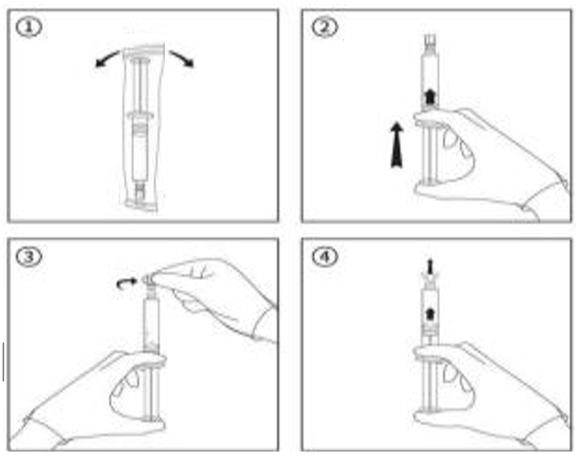**

1. Open the package using aseptic technique. (Figure 1)
2. With the tip cap still in place, gently depress the plunger to reduce resistance. (Figure 2)
3. Twist off the syringe tip cap. (Figure 3)
4. Hold the syringe upright and expel any air bubbles. (Figure 4)
5. Attach the syringe to the IV access device, such as a valve, port, or needleless connector, and flush according to institutional protocols and policies.
6. Discard the used syringe and any remaining solution after use. Do not reuse.
7. This product is only supported to be used with products that comply with ISO 80369-7 Luer Connection design.
8. **Shelf Life**

Two years from the date of production.

1. **Clinical Benefits**

HP Flush TM 0.9% Sodium Chloride Injection Flush Syringe is a pre-filled, single use 0.9% sodium chloride syringe that helps to improve clinician efficiency by eliminating steps and time involved in the manual preparation of saline syringes.

HP Flush TM 0.9% Sodium Chloride Injection Flush Syringe reduces risk of touch contamination that may occur during manual preparation of saline flush syringes.

1. **Reporting of Serious Incidents**

In accordance with Medical Device Regulation (EU) 2017/745, any serious incident involving this device must be reported to the manufacturer and the competent authority of the Member State in which the user or patient is located.

1. **Disposal of Medical Waste**

Dispose of the used device and any residual solution in accordance with applicable local regulations on medical waste within the relevant EU Member State.

1. **Date of Issue of the IFU**

The date of issue of this IFU is 2025/08/24. Information regarding the latest revision is available in the device's technical documentation.

1. **Symbols and Their Meanings**

The following symbols are used on the device labeling and packaging. Definitions are provided in accordance with ISO 15223-1 and applicable regulatory guidance:

|  |  |
| --- | --- |
| **Graphic** | **Title** |
|  | Manufacturer |
|  | Batch code |
| D:\Backup\Documents\WeChat Files\wxid_zsyixh9j4f5322\FileStorage\Temp\b7ccab44c0bc35bf1b08bc5d3895cbe.png | Authorized representative in the European Union |
|  | Catalogue number |
| 1726294260523 | Non-pyrogenic |
|  | Keep away from sunlight |
|  | Keep dry |
|  | Fragile, handle with care |
|  | This way up |
|  | Sterilized using steam or dry heat |
|  | Sterile fluid path |
|  | Contains no natural rubber latex |
|  | DEHP-free |
|  | Medical device |
|  | Do not use if package is damaged and consult instructions for use |
|  | Do not re-use |
|  | CE marking with notified body code |
|  | Date of manufacture |
|  | Use-by date |
|  | Caution |
|  | Consult instructions for use |
|  | Do not resterilize |
|  | Unique device identifier |
|  | Temperature limit (20 ℃ to 25 ℃) |
| 1749704650627 | Sterile fluid path sterilized using steam or dry heat; single sterile barrier system with protective packaging outside |
| 1749705410930 | Sterile fluid path sterilized using steam or dry heat; single sterile barrier system |